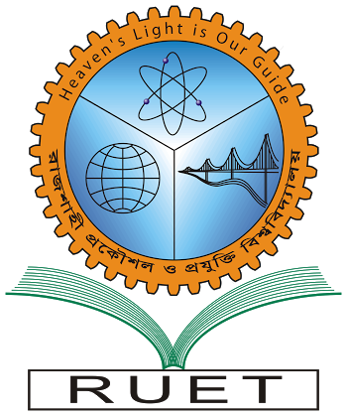“Heaven’s light is our guide”

**Rajshahi University of Engineering & Technology**

**Department of Computer Science & Engineering**

**Course Title: Numerical Method Sessional**

**Course No: CSE 2104**

Submitted To:

***Sadia Zaman Mishu***

*Assistant Professor,*

*Dept. of CSE,*

*RUET.*

Submitted By:

***Saifur Rahman***

*Roll No:* ***1703018***

*Section: ’17-A*

*Class:2nd year (Odd Semester)*

***Date of Submission: 3rd September, 2019***